NASA SPINE INSTITUTE
R. Eric Santos M.D.
Orthopedic Spine Surgeon

Pain Diagram
Mark on the diagram below where your pain is located

Burning Numbness Pain Tingles Aching Weakness Cramping
______________________________________________________________________________________

BBBBBBB NNNNNNNN PPPPPPP TTTTTTTTT AAAAAAA WWWWW CCCCCCCC

FRONT BACK
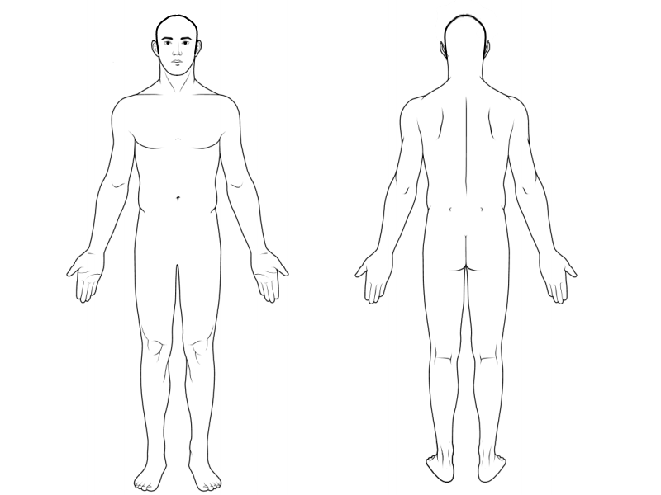

Right Left Left Right

Do you have more Back/Neck or Leg/Arm Pain? __________________________________________
How much of your pain is in the Back/Neck ___________% Leg /Arm ____________%
(the total number of two percentages % above must equal 100%)

Patient Name: __________________________________ Today’s Date: ___________________________________

NAME _______________________________________________________________________________
Last (please print) First Middle Initial

DOB: _______/________/________ SS#: _________-_________-___________

- What is your main complaint? Please be detailed

__________________________________________________________________________________________
__________________________________________________________________________________________
- Check the word(s) which describe your pain?
- Burning | - Pulling | - Sensitive | - Stabbing
- Aching | - Hot poker | - Tiring | - Heavy
- Stinging | - Sharp | - Penetrating | - Electric
- Throbbing | - Jabbing | - Numbing | - Itching
- Shooting | - Pin & needles | - cramping | - weakness
- Stiff | - Sore | - Dull | - Pressure-like
- When did you first notice the symptoms? Was there any event that brought on the symptoms?
__________________________________________________________________________________________
- How do your symptoms affect your life and daily activities? ___________________________________________________________________________________________
- Did you neck/back pain started suddenly or come on slowly? __________________________________________
- What triggers your pain? _______________________________________________________________________
- Hoe has your neck/back pain changed since it started? (Better, worse or same) ___________________________
- Do you have any muscle weakness or the feeling of an inability to move? ________________________________
- Have you had numbness or tingles in your upper limbs/ lower limbs? ___________________________________
- Have you had any pain in your upper limbs/lower limbs? _____________________________________________
- Is your back/neck pain worse with certain movement (circle the ones that apply)?
bending forward/backward twisting Raising arms above head
lifting or carrying a load bending to the left/ right side
- When does your pain occur (circle the ones that apply)?
Constant Occasionally without warning
With stress at the same time each day when I move a certain way

- How do you rate your pain on a scale of 0 to 10? One being no or little pain and 10 being the worst pain you’re experienced. Please circle one

0 1 2 3 4 5 6 7 8 9 10

- Do you or have you ever had any bowel or bladder problems? __________ NO __________ YES
If yes, please describe ______________________________________________________________________
- Do you use a cane, walker or wheelchair? _____________________________________________________

- How long can you stand? ___________________________________________________________________

- How long or how far can you walk? ______________________ Do you have trouble walking? YES____ NO ____

- What makes your pain better? _______________________________________________________________

- What makes your pain worse? _______________________________________________________________
- Does sneezing, coughing or bowel movements make your pain worse? __________ NO __________ YES

- Do you have any unexplained weight loss or gain, fever, chills or night sweats? ________ NO _________ YES

- Does your pain wake you up at night after you have gone to sleep? _________ NO _________ YES

- Is your pain worse in the morning and improves after you “loosen up”? _________ NO _________ YES

- Does lying down help relieve the pain? _________ NO _________ YES

- Does your pain get worse as the day progresses? __________ NO ___________ YES

- Do you wear a shoe lift? Right _________ NO ___________ YES Left _________ NO ________ YES
- Do you have heart problems? __________ NO ___________ YES

- Do you see a cardiologist? ___________ NO ____________ YES

- Do you have any other medical problems that we should know about?
- High cholesterol | - High blood pressure | - Peripheral neuropathy | - Poor circulation | - Irritable bowel
- Overweight | - Epilepsy/seizures | - Easy bruising/bleeding | - Irregular heart beat | - Stomach ulcers
- Depression/anxiety | - Panic attacks | - Skin disease | - Heart attack | - hepatitis
- thyroid disease | - sleep apnea | - Diabetes | - Heart failure | - Lung disease
- Reflux/Gerd | - AIDS/HIV | - Kidney Disease | - Stroke | - Osteoporosis
- Other

- Have you been treated for your spine condition at another location? __________ NO ___________ YES
Please describe the treatment you received. (I was sent to physical therapy on November 10, received 10 treatments which consisted of hot packs, ultrasound and back exercises, or I saw Dr. Smith at Internal Medicine on October 10, 1993 who sent me for an MRI, etc. Also check all that apply)
- Chiropracter | - Physical Therapy | - Acupuncture | - Massage | - injections

- Are you involved in any litigation involving your injury? __________ NO ____________ YES
Please describe: _____________________________________________________________________________

Medical History
Height: __________________ Weight: _________________ Bp__________________
What doctor(s) have you seen about your present condition? __________________________________________
_____________________________________________________________________________________________
Which doctor referred you? ______________________________________________________________________
Phone: (________) __________-___________ Fax: (_________) __________-___________
Family Physician: _______________________________________________________________________________
Phone: (_________) _________-_________ Fax: (__________) ____________-_____________
Do you have a Pain Management doctor? ___________________________________________________________
Phone (_______) _________-___________ Fax: (_______) __________-______________

List current medications; including prescriptions over the counter, vitamins and herbals:
MEDICATION | DOSAGE

List any surgeries and/or injuries from the past to present:
SURGERY/INJURY | Date

Do you have any food allergies? _____________ NO ___________ YES
If yes, please specify: ____________________________________________________________________________

Do you have any drug allergies? _________ NO ___________ YES
If yes, please specify: _____________________________________________________________________________

Do you smoke? ____________ NO ___________ YES
How many packs per day? ____________

Do you drink alcoholic beverages? _____________ NO ____________ YES
What kind of beverages? Wine Beer Cocktails Liquor
How often do you drink? _____________ Heavy (5+ drinks/day)
_____________ Everyday (3+ drinks/day)
_____________ Occasionally (1-2 drinks/day)
_____________ Socially
_____________ None
Marital Status? Married Single Divorced Widow
Number of Children? 0 1 2 3 4 5 6 7 8 9 10
Family History: Mother Father Brothers Sisters children
Heart disease: _____________________________________________________________________________
Hypertension: _____________________________________________________________________________
Stroke: ___________________________________________________________________________________
Cancer: ___________________________________________________________________________________
Diabetes: _________________________________________________________________________________
Glaucoma: ________________________________________________________________________________
Epilepsy: __________________________________________________________________________________
Bleeding Disorders: _________________________________________________________________________
Kidney Disease: ____________________________________________________________________________
Thyroid Disease: ____________________________________________________________________________
Mental illness: ______________________________________________________________________________
Osteoporosis: ______________________________________________________________________________
Back Problems: _____________________________________________________________________________
Living: ____________________________________________________________________________________
Deceased: _________________________________________________________________________________

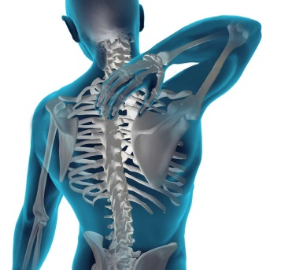
PHARMACY INFORMATION
R. Eric Santos M.D
Kim J Garges M.D
333 N. Texas Ave Ste 3200
Webster TX 77598
PH: 281-333-2727
Fax: 281-333-2828

Name_____________________________________________________
DOB_______________________________________________________
Pharmacy Name______________________________________________
Pharmacy Number____________________________________________
Pharmacy Address____________________________________________
Allergies ___________________________________________________
This information will be used for submission of electronic prescripts to your listed pharmacy

NASA SPINE INSTITUTE: R. Eric Santos / Kim J Garges
333 N. Texas Ave Ste 3200 Webster TX 77598
Disclosure and Authorization Form for
Patient Referral to Other Non-Participating Physician(s) or Facility

Patient Name: ________________________________ Physician Name: ________________________________
Diagnosis: ___________________________________ Other Physician: ________________________________
For Treatment: _______________________________ Other Entity: ___________________________________
Patient Plan In-Network: _______________________ Location: ______________________________________

Dear Patient:

In order to better serve you with the highest care quality and safety at most affordable cost, sometimes it is necessary and important to have other or more provider(s) or entities to join our team to complete or continue your medical procedures or treatment in order to ensure the speedy recovery for you. We would like to keep you informed of your choice and our recommendation of these other providers(s) or entities and obtain your informed authorization before referral and scheduling for your next treat procedure(s).

While no provider or entity could be participating every managed care network, such as the one your health plan has contracted with, these other provider(s) or entities may or may not be in your health plan’s network. This form is used to inform you of our verification that the above named provider(s) or entities are non-participating provider(s) or entities with your health plan.

We have verified your insurance coverage for non-participating provider(s) or entities and the recommended treatment procedure(s) and obtain pre-certification if applicable for all services as a courtesy to you.

Please understand that the insurance verification is not a guarantee of insurance payment according to your health plan.

If you have any question concerning whether you have out of network benefits or your financial obligation under your benefit plan if you use an out of network provider, please call the member services number on your Insurance Identification Card.

Compliance & Disclosure under Texas occupations Code-section 102.006
In compliance with Section 102.006 of Texas Occupations Code in connection with my informed consent and personal choice of doctors and facility solely based on the quality and safety of care, reputation of patient satisfaction, and my knowledge in my decision-making in exercising my right with respect to the in-network or out-network coverage and cost sharing, my attending doctors(s) and/or clinic (facility) have disclosed to me at the time of initial contact and at the time of referral with respect to choice of a doctor or facility solely in interest of my healthcare quality and safety, as a result of my informed consent and personal choice of doctor(s) and / or facility : (A) his/her affiliation, if any, with the doctor or facility for whom the patient is referred and (B) that he / she will receive, directly or indirectly, remuneration for referring upon my such request and exercising my rights of freedom of choice for the provider(s) and facility under the in-network or out-network coverage as provided by my health plan, in compliance with all applicable federal and state laws, Medicare, ERISA, PPACA and the Section 102.006 of Texas Occupations Code.
Doctors or Facility with affiliation and remuneration: ________Houston Physician Hospital______________________________
I certify that I was informed of the effective alternative resources available at the time of my decision-making, and my option to use one of the alternative resources, and that I was assured by my attending physician that I will not be treated differently by the physician and his staff if I choose an alternative provider or entity.
I certify that my attending physician(s) has made referrals to the other non-participating providers or entities based only on the needs of my individual healthcare, the medical community standard of care and my informed choice for quality and safety of the care that I will be expecting and receiving, and for provider’s professional reputation and patient satisfaction in order to provide me with quality and affordable healthcare that I personally expected under my health plan for out-of-network coverage.
I have read and fully understand this Disclosure and Authorization Form. I hereby authorized this referral to non-participating out-of-network provider(s) or entities as named above.
____________________________________________________________________________________________________________
Patient Name (print) Signature of Patient Date
Nasa Spine Institute
333 N. Texas Ave Ste 3200
Webster TX 77598
Tel: 281-333-2727 Fax: 281-333-2828

Authorization to Release Medical Information
Date: ________________

Patient Name: _________________________________________________________
DOB: __________________________ SS#: _______________________
I __________________________________ hereby authorize the release of my medical records or in addition, request they be sent to:
Information being requested:
☐ Entire record file
☐ All Clinic notes
☐ EMG/NCV
☐ Laboratory reports
☐ Radiology studies (MRI, X-Ray, CT Scans, Etc.)
☐ OP Reports, Injection reports, Etc.

☐ I am authorizing this information to be faxed.
☐ I am authorizing this to be mailed to the above Facility.
☐ I will be picking up imaging disk/imaging report.
☐ I am authorizing these imaging disk/imaging report to be picked up by ____________________

Relationship to patient: ________________ CONTINUED MEDICAL CARE
__________________________________ _______________
Signature of Patient or Patient Guardian Date

__________________________________ _______________
Signature of office Representative Date

Nasa Spine institute
R. Eric Santos MD
Kim J Garges MD

DISCLOSURE OF INFORMATION
I, ________________________________________________, give permission for this office to leave detailed messages on the answering service/voicemail messaging at:
□ My home (please initial) _________________ □ My cellular phone (please initial) _________________
What is the best phone number for us to contact you? ____________________________________________________________________________________________________________________
TO BE COMPLETED BY THE PATIENT:
I authorize the following individuals to be involved in the discussion of my medical health
information and relieve Nasa Spine Institute of any responsibility for harmful neglect
(release of medical health information) by my authorized companion(s):
Name: Relationship to Patient
_____________________________________________ ___________________________________________________________
_____________________________________________ ___________________________________________________________
_____________________________________________ ___________________________________________________________
_____________________________________________ ___________________________________________________________
_____________________________________________ ___________________________________________________________
_____________________________________________ ___________________________________________________________
_________________________________________________ ________________________________________________________________

Patient Name:______________________________________________________________________
Patient Signature:_______________________________________________________ Date: ____________________________

ACKNOWLEDGEMENT OF REVIEW OF NOTICE OF PRIVAY PRACTICE
By signing below, I acknowledge that I have been provided with a copy of the Nasa Spin Institute's. Notice of Privacy Practices and have therefore been advised of how health information about me may be used and disclosed by Nasa Spine Institute and how I may obtain access to and control this information.

________________________________________________________________ _________________________________________
Print name of patient Date

_________________________________________________________________ __________________________________________
Signature of patient Date

General Acceptance of Liability
I, _________________________________________________________, all professional services rendered are charged to the patient insurance. The patient is responsible for all fees, regardless of insurance coverage. In the
event of collection proceedings due to lack of payment on my part, I agree to pay any and all collection fees that may be added to my account in order to recover money due to Kim J Garges, MD & R. Eric Santos, MD.
Our office will file insurance for all reimbursable services, to both your primary and secondary insurance carriers. Please remember that you are responsible for all deductible, copay, and non-covered service amounts.
The undersigned guarantees payment in full. Guarantor understands all patients including those with Medicare or other insurance, are personally responsible for the balance after the insurance company has made payment. I hereby assign and direct you to pay any surgical or medical benefits under
claims submitted directly to Kim J Garges, MD & R. Eric Santos, MD I also authorize the release of any medical records or information requested by the insurance companies in connection with the above assignments. I understand that my doctor has no obligation to my attorney to furnish consult, narrative reports, or depositions. I also understand that under no circumstances, will my doctor appear as a witness in court on my behalf.
________________________________________________________________ _________________________________________
Print name of patient Date

_________________________________________________________________ __________________________________________
Signature of patient Date

